Meicheng
®
^{www.meicheng.com.tw}

PV -Serial Portable
MPEG-4 Video Recorder

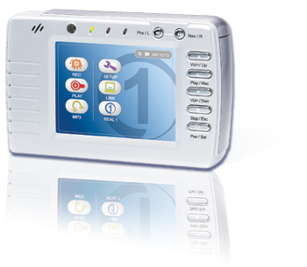

- Video player/ recorder (MPEG-4)
- MP3 player
- Photo wallet
- Digital Voice Recorder
- Data storage center
- Built-in 40/80 GB Hard Drive
- 3.5” LCD backlight panel
- Real One player
- Rechargeable & removable battery

Immediate access to all your favorite entertainment – anytime and anywhere

PV-Serial is the first one and the only one portable video player in the world that implements Real One player. This improvement enhances PV operational interface to be user-friendly and attractive.

Personal Video Recorder/Player
Simply record from any audio, video resources such as TV, DVD/VCD player, or VCR and convert them in real-time into high-quality MPEG-4 videos. With its built-in 80GB HDD, it is able to record up to 160-hour videos. Videos can be watched from its built-in 3.5” LCD backlight screen or output to TV.

Photo Wallet
Store over 400,000 digital photos (1,600x1,200 pixels) and show them to your family and friends either on its built-in screen or TV. You can transfer photos from digital cameras, PCs, to PV instantly via USB2.0 port. Supported functions include zoom in, zoom out, thumbnail, and auto slideshows.
Storage Capacity: | 2.5” 40/80 GB Hard Drive
Memory: | 2M Flash, 64 MB SDRAM (PV-390)
Video Recording: | MPEG-4
Video Resolution: | 320x240 pixels
Video Playback: | MPEG-4
Capture rate: | 25~28 fps
Music Playback: | MP3, RA
Audio Recording: | G.726
Photo Viewer: | JPEG (Baseline)
Display: | 3.5'' LCD with LED Backlight Screen,  480X234 pixels
AV Connections: | Composite line in  Composite line out  Earphone
Interface: | High speed USB 2.0
Software Included: | Real One Player
Scalability: | Downloadable firmware
Power: | 12V-DC IN, 100-240V AC Adaptor
Battery: | 7.4V 1,360mAh rechargeable Li-Ion
Playback Autonomy: | 2 hr in video playback
Dimensions: | 130(W) x 84(H) x 33(T) mm (PV-330)
Weight: | 350g
MP3 Music Player
Transfer your entire MP3 files via USB2.0 cable to PV. Capacity of holding is up to 1,480 hours (24,000 songs) MP3 music. You can enjoy the non-stop music without hearing the same song twice.

USB Hard Drive
The device is automatically mounted as an additional Hard Drive to your PC. You can drag and drop your data and bring it with you anywhere. It can store any files and serve as a great massive backup device.
PV-330:
Built-in 3.5” Color LCD, 20/40/80 GB 2.5” internal Hard disk, Rechargeable/ Removable Lithium-Ion Battery.

Dimension: 130 x 84 x 33 mm
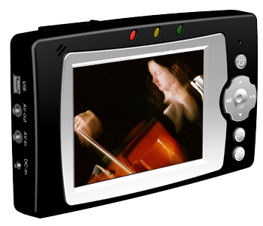 | PV-390-1:  Built-in 3.5” Color LCD, 40/80 GB 2.5” replaceable Hard disk, SD Card reader, Twin speakers, stand, Rechargeable/ Removable Lithium-Ion Battery.  Dimension: 145 x 80 x 23 mm
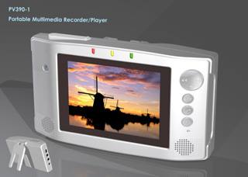
Specifications are subject to change without notice. Images and illustrations may not always match contents. Trademark registered. All rights reserved.

Shipping Information

Package is as shown:
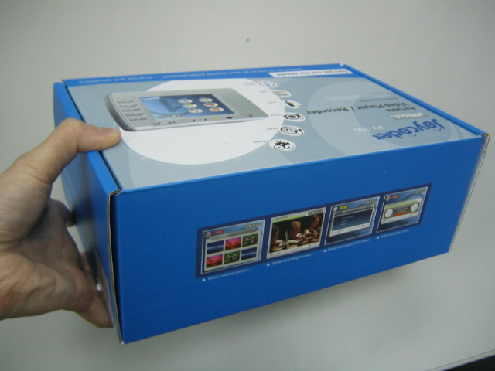
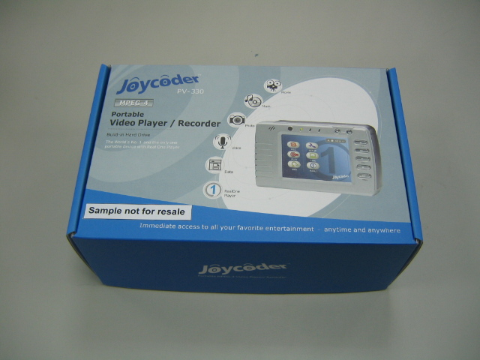

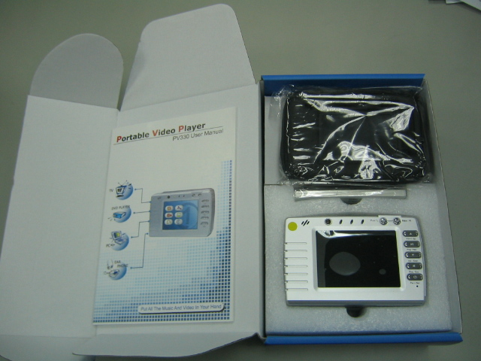

1 package dimension: 26 x 10 x 17 cm
Weight (per unit): 1.1kg

Carton dimension (10 packs): 52 x 36 x 37 cm
Weight: 11.5kg

Warranty:

PCB: 24 month
LCD panel, HDD: 14 month

Li-Ion battery: 12 month

Meicheng® MEI CHENG AUDIO VIDEO CO., LTD
Address:5F. , NO.111 , SEC.2 , HUAN HO N. RD., TAIPEI , 10376 TAIWAN
Tel: +886(2) 2585 3869, Fax: +886(2) 2593 6672
Website: www.meicheng.com.tw Email:mei.cheng@msa.hinet.net

