Conference System
GM-30
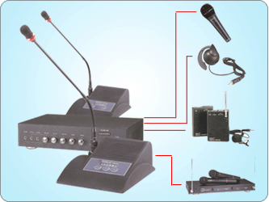

FEATURE:

1."PRIORITY TO TALK" FUNCTION KEY

2. POWER & VOLUME INDICATING LIGHT

3. GOOSENECK MICROPHONE IS SECURED ON BASE WITH "SCREW-TIGHT" FASTENING RING

4. RED LIGHT RING ON MICROPHONE TO INDICATE IF THE MIC IS "ON"

5. AUTOMATIC "SHUT OFF" 25 SECONDS AFTER NOT SPEAKING

6. WINDSCREEN(INCLUDED) TO KEEP FROM "POP" NOISE
SPECIFICATION:
POWER CONSUMPTION : DC24V 70MA
MAX. OUTPUT: 1.5W
SPEAKER: 3 WATT
BASE SIZE: 200MMX165MMX85MM
WEIGHT: 0.65KGS
*ACCESSORIES: 2M CABLE OPTIONAL
(6P RECEPTACLE CONNECTOR ON BOTH ENDS)

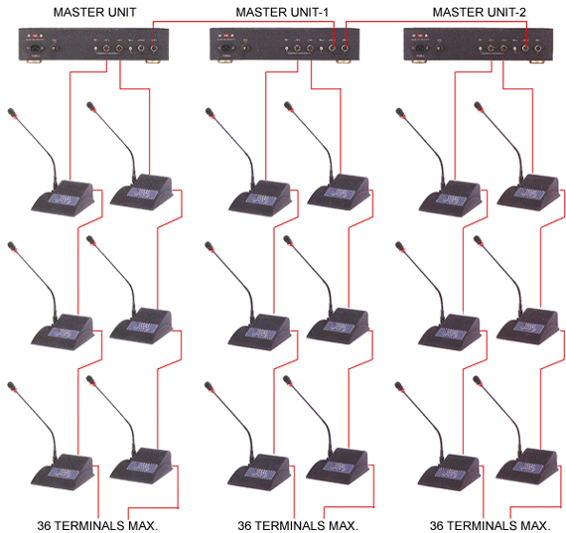

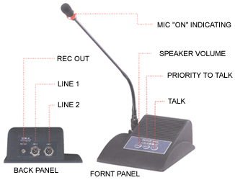 | 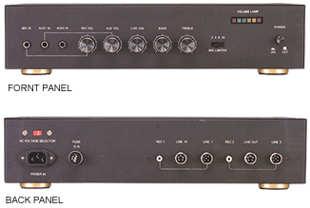
Delegate Unit  GM-30a  FEATURE:  * POWER & VOLUME INDICATING LIGHT  * GOOSENECK MICROPHONE IS SECURED ON BASE WITH "SCREW-TIGHT" FASTENING RING  * RED LIGHT RING ON MICROPHONE TO INDICATE IF THE MIC IS "ON"  * AUTOMATIC "SHUT OFF" 25 SECONDS AFTER NOT SPEAKING  * WINDSCREEN(INCLUDED) TO KEEP FROM "POP" NOISE  SPECIFICATION:  POWER CONSUMPTION: DC24V 70MA  MAX. OUTPUT: 1.5W  SPEAKER: 3 WATT  BASE SIZE: 200MMX165MMX85MM  WEIGHT:0.65KGS  ACCESSORIES: 2M CABLE OPTIONAL  (6P RECEPTACLE CONNECTOR ON BOTH ENDS) | Master Control Unit  GM-30s  FEATURE:  * IT HAS A BUILT-IN POWER SUPPLY AND SIGNAL AMPLIFYING TO SUPPORT PRESIDENT/DELEGATE UNITS.  * LINE IN/LINE OUT (AT BACK PANEL) FOR SIGNALS INPUT/OUTPUT, TO CONNECT ANOTHER MASTER UNIT.  * TWO INDEPENDENT CIRCUIT DESIGNED SOCKET BUILT (LINE1, & 2 AT BACK PANEL), EACH CAN CONNECT DELEGATE UNIT UP TO 36 SETS IN SERIAL.  * TWO SOURCE OUTPUTS-RCA JACKS(REC 1,2, AT BACK PANEL) FOR MONITORING (RECORDING) OR OTHER APPLICATIONS  * THREE SOURCE INPUTS-RCA JACKS: MIC IN, AUX1 IN, AUX2 IN, 2 OF THEM (MIC IN/AUX1 IN) HAVING VOLUME CONTROL (CAN BE FOR MICROPHONE'S DIRECT INPUT OR OTHERS) THE 3 RD INPUT (AUX2 IN) CAN BE USED AS A SOUND SOURCE TO BROADCAST OR PLAY MUSIC.  SPECIFICATION:  POWER SUPPLY: AC 110/220 VOLTAGE SELECTOR  RATED POWER CONSUMPTION: 150W  S/N RATIO: 60DB

Meicheng MEI CHENG AUDIO VIDEO CO., LTD
Address:5F. , NO.111 , SEC.2 , HUAN HO N. RD., TAIPEI , 103 TAIWAN
Tel: +886(2) 2585 3869, Fax: +886(2) 2593 6672
Website: www.meicheng.com.tw Email:mei.cheng@msa.hinet.net

