Meicheng DV-REPEATER

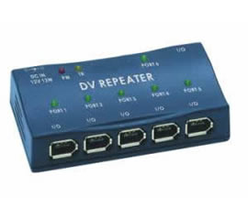

Features
1.Supports IEEE 1394-1995 Standard and the P1394a.Supplement for High performance Serial Bus
2.Six P1394a Fully Compliant Cable Ports at 100/200/400 Megabits per Second (Mbits/s).
3.Fully Interoperable with the FireWire(TM) and iLINK(TM). Implementation of IEEE Std 1394.
4.Self-Powered or Cable-Powered mode.
5.Plug and Play compatible.
6.Asynchronous and isochronous data transfers.
7.Works with PC Windows 98/SE/ME/XP /2000 systems and iMac systems IEEE1394 interface external expansion.

Meicheng MEI CHENG AUDIO VIDEO CO., LTD
Address:5F. , NO.111 , SEC.2 , HUAN HO N. RD., TAIPEI , 103 TAIWAN
Tel: +886(2) 2585 3869, Fax: +886(2) 2593 6672
Website: www.meicheng.com.tw Email:mei.cheng@msa.hinet.net

