Meicheng® CPT-370 / PC to Video Overlay

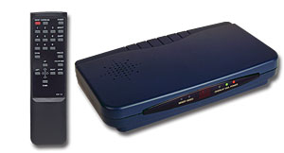 | 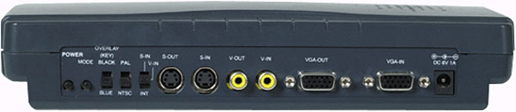

Applications:
1.Superimpose PC text/graphic onto video.
2.Mix PC picture and Video.
3.Enjoy PC games, PC movies and Internet on TV.
4.Education and business presentation.
5.Add text and graphic to your home or corporate video.

Features:
1.Superimpose PC text and graphics onto another channel of live video.
2.It converts three VGA modes - 1024x768, 800x600, 640x480 into NTSC or PAL and then mix or keying with another video.
3.Plug-and-play design, no software drivers required.
4.Cross-platform compatibility for PC, Macintosh and Notebook.
5.Zoom & Pan.
6.Vertical and horizontal overscan/underscan control.
7.Simultaneous display on PC and TV monitor.
8.Composite, S-Video (S-VHS or Hi-8) output.
9.Automatically supports scan rate from 50 Hz up to 100Hz.
10.With easy touch remote control.

Meicheng MEI CHENG AUDIO VIDEO CO., LTD
Address:5F. , NO.111 , SEC.2 , HUAN HO N. RD., TAIPEI , 103 TAIWAN
Tel: +886(2) 2585 3869, Fax: +886(2) 2593 6672
Website: www.meicheng.com.tw Email:mei.cheng@msa.hinet.net

