Meicheng
®
^{www.meicheng.com.tw}
CM-331

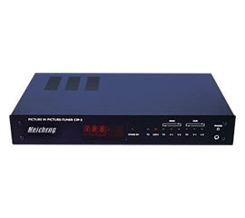 | 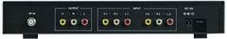
Applications:
CIP-3 allows you to view two video signals on your TV screen at the same time from two external sources, such as VCRs, DVD players, camcorders…etc. A built-in 181-channel TV tuner allows you to view two favorite video programs on your TV screen at the same time or monitor video from a camera while viewing a video program.

Features:
1.Real time high-resolution picture in picture display for TV and two video inputs.
2.4 PIP sizes selectable for the sub-picture.
3.PIP channel may be placed in 9 different positions of the screen.
4.Still for PIP.
5.Main and PIP channel can be swapped by simply pressing a button.
6.Stereo sound on both main channel (TV mono) and PIP channel.
7.Ear-phone audio out for PIP channel.
8.Built-in TV/CATV tuner for selecting any of the air or cable channels.

Meicheng® MEI CHENG AUDIO VIDEO CO., LTD
Address: 5F., NO.111, SEC. 2, HUAN HO N. RD., TAIPEI, 10376 TAIWAN
Tel: +886(2) 2585 3869, Fax: +886(2) 2593 6672
Website: www.meicheng.com.tw Email:mei.cheng@msa.hinet.ne

Meicheng MEI CHENG AUDIO VIDEO CO., LTD
Address:5F. , NO.111 , SEC.2 , HUAN HO N. RD., TAIPEI , 103 TAIWAN
Tel: +886(2) 2585 3869, Fax: +886(2) 2593 6672
Website: www.meicheng.com.tw Email:mei.cheng@msa.hinet.net

